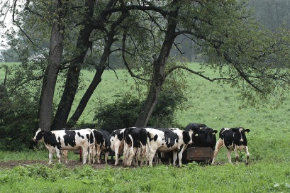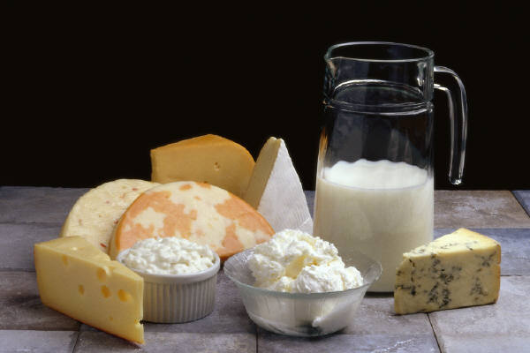
Sources of Bacterial Contamination in Raw Milk
Test Result |  | Natural Bacteria | Mastitis Bacteria | Dirty Udders | Dirty Equipment | Poor Cooling
 | SPC\CFU > 10,000 | Doubtful | Possible | Possible | Possible | Possible
 | SPC\CFU > 100,000 | Doubtful | Possible | Doubtful | Likely | Likely
 | LPC > 300 | Doubtful | Doubtful | Possible | Likely | Doubtful
 | PI high, 3-4X SPC | Doubtful | Doubtful | Possible | Likely | Likely
 | SPC\CFU High >/=PI | Doubtful | Presumed | Doubtful | Doubtful | Doubtful
 | Coli Count > 100 | Doubtful | Possible | Possible | Possible | Doubtful

PPLC\SPC\CFU=Petrifilm Plate Loop Count, Standard Plate Count, Colony Forming Units
LPC=Lab Pasteurized Count PI=Preliminary Incubations Coli Count=Coliform Bacteria

Source: Standard Methods for the examination of Milk

